 | HOSPITAL MANAGEMENT SYSTEM  Technical Design Document  1.0
 | Prepared By | Last Updated By | Reviewed By 1 | Reviewed By 2 | Approved By
Name | Charu Dhingra | Lucky Sharma | Abhinav Kumar | Dhanakshi Jain | Divanshu Sharma
Role | Team Member | Team Member | Team Member | Team Member | Scrum Master
Signature
Date | April 12,2019 | April 12,2019 | April 12,2019 | April 12,2019 | April 12,2019

Table of Contents

1.0 Introduction 3
1.1 Purpose of this document 3
1.2 Scope 3
1.3 Intended Audience 3
2.0 Conventions and Standards Followed 4
3.0 Assumptions, Dependencies and Risks 4
3.1 Assumptions: 4
3.2 Dependencies: 4
4.0 Schematic Diagram 4
5.0 Use Case Realization 5
5.1.1 Admin Registration 5
a. Functional Requirement 6
b. UI Validations 6
c. UI Controls 7
d. UI Methods Definition 8
e. UI Design 9
6.0 Database Design 9
6.1 Tables Structure 9
7.0 Change Log 13

Introduction

Purpose of this document
The purpose of the detail design document is to define the detailed design for all the components of Hospital Management System that are specified in the Business Requirement/Use case document. All the low level components, interfaces and integrations are detailed out in this document.

Scope
This sub-section shall state the scope of this detailed design document
• Create and maintain Login information.
• Create and maintain Patients information
• Create and maintain Physician information
• Create and maintain Patients Diagnosis information

Intended Audience
The intended audience for this document are
- Developers, testers, other associates in the project
- Technical lead, Scrum Master
- Product Owner

Conventions and Standards Followed
The modules under scope needs to adhere to the coding standards and guidelines


Assumptions, Dependencies and Risks

Assumptions:
- Once the application is built the HOSPITAL MANAGEMENT SYSTEM will manually load the user list into the system.
- There will be no concurrent ADMIN for the application. The Patient profile will be maintained by the ADMIN.
- Any changes to the design mentioned in the BRD would be taken as a Change Request

Dependencies:
- Availability of database design characteristics & access shall be defined by the
- Resource availability throughout each of the sprint

Schematic Diagram
A schematic, or schematic diagram, is a representation of the elements of a system using abstract, graphic symbols rather than realistic pictures. It gives an overview of overall system
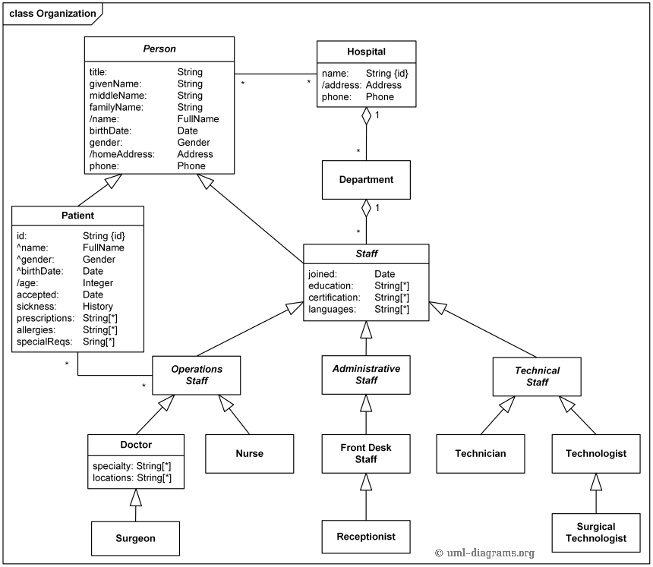
The above pic is only an example and not representational of the Hospital Management project.

Use Case Realization

Admin Registration

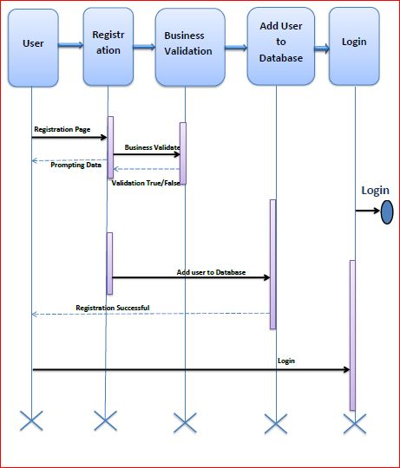

Functional Requirement
. Login Page checks the authentication of the user and based on his role, directs the admin to the respective page. Admin will provided with Add Patient , Physician and Patient Details, Regulation and Search regulation pages and the same user will allowed to see Diagnosis Reports and patient vital parameters reports

UI Validations
- Admin Id and Password fields are mandatory.
- Invalid Admin Id and / or password should not allow the user to get into the system

UI Controls
# | UI Component | Type | Name | Details
1 | Admin Id | Label | label_For_User_Id
2 | Admin | Text field | Textfield_user | To enter username
3 | password | Label | Label_for_password
4 | password | Text field | Textfield_password | To enter password

UI Methods Definition
Method Name | Parameter | Details
Signup Button Click | object sender, EventArgs e | Allows the user to login into the portal and register the patient.
Reset Button Click | object sender, EventArgs e | Clears the details entered by the user.
Home Button Click | object sender, EventArgs e | Loads the Homepage after registration is done successfully.
Register Button Click | object sender, EventArgs e | Allows the Admin to insert the Admin personal details
Reset Button Click | object sender, EventArgs e | Resets all fields given by Admin.
Add patient Button Click | object sender, EventArgs e | Allows the Admin to add patient details
View patient Button Click | object sender, EventArgs e | Allows the Admin to view the details of patient present in database
Add physician Button Click | object sender, EventArgs e | Allows the Admin to add Physician Details
View physician Button Click | object sender, EventArgs e | Allows the Admin to view physician details present in the database
Add Diagnosis Button Click | object sender, EventArgs e | Allows the Admin to add Diagnosis Details of the patient
Patient History | object sender, EventArgs e | Allows the Admin to view Patient history

UI Design
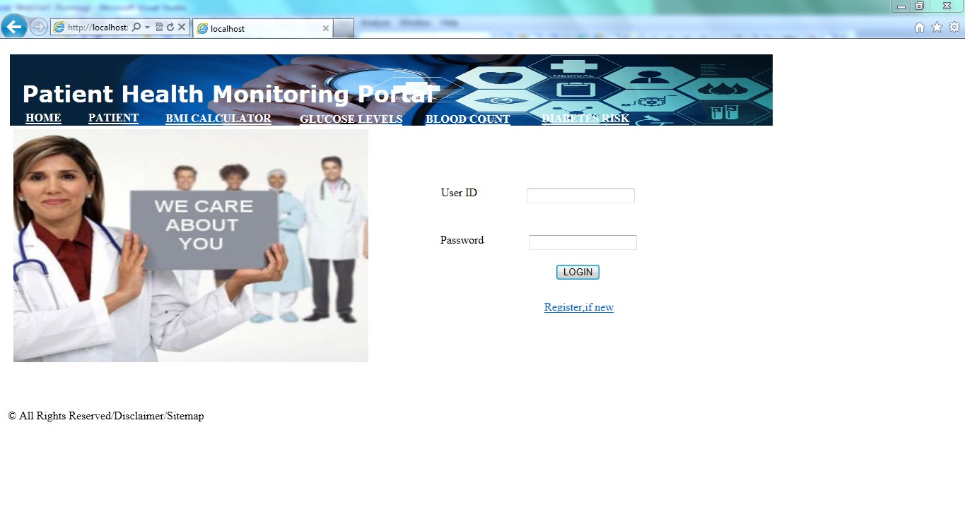

Database Design

Tables Structure
Admin Registration:
Column Name | Data Type | Length | Nulls
Admin Id | Varchar | 50 | N
First Name | Varchar | 50 | N
Last Name | varchar | 50 | N
Age | Int | 5 | N
Gender | Varchar | 10 | N
Date of Birth | Date | 50 | N
Contact Number | Varchar | 10 | N
Alt Contact Number | Varchar | 10 | N
Email | Varchar | 50 | N
Password | Varchar | 50 | N

Patient:
Column Name | Data Type | Length | Nulls
Patient Id | Varchar | 10 | N
Firstname | Varchar | 50 | N
Lastname | Varchar | 50 | N
Age | Varchar | 2 | N
Gender | Varchar | 2 | N
Date Of Birth | Date | 30 | N
Contact Number | Varchar | 10 | N
Alt Contact Number | Varchar | 10 | N
Email | Varchar | 50 | N
Password | Varchar | 20 | N
Address Line 1 | Varchar | 250 | N
Address Line 2 | Varchar | 250 | N
City | Varchar | 50 | N
State | Varchar | 20 | N
Zipcode | varchar | 10 | N

Physician:
Column Name | Data Type | Length | Nulls
Physician Id | Varchar | 10 | N
Firstname | Varchar | 50 | N
Lastname | Varchar | 50 | N
Age | Varchar | 2 | N
Gender | Varchar | 2 | N
Date Of Birth | Date | 30 | N
Contact Number | Varchar | 10 | N
Alt Contact Number | Varchar | 10 | N
Email | Varchar | 50 | N
Password | Varchar | 20 | N
Address Line 1 | Varchar | 250 | N
Address Line 2 | Varchar | 250 | N
City | Varchar | 50 | N
State | Varchar | 20 | N
Zipcode | Varchar | 10 | N
Degree | Varchar | 50 | N
Speciality | Varchar | 50 | N
Work Hours | Varchar | 50 | N
Hospital Name | Varchar | 100 | N

Patient Diagnosis Details:
Column Name | Data Type | Length | Nulls
Report Id | Number | 10 | N
Patient Id | Varchar | 50 | N
Physician Id | Varchar | 50 | N
Service Date | Date | 20 | N
Test Result Date | Date | 20 | N
Date Of Birth | Date | 30 | N
Blood_WBC_AR | Varchar | 20 | N
Blood_WBC_NR | Varchar | 20 | N
Blood_RBC_AR | Varchar | 20 | N
Blood_RBC_NR | Varchar | 20 | N
Blood_HGB_AR | Varchar | 20 | N
Blood_HGB_NR | Varchar | 20 | N
Blood_HCT_AR | Varchar | 20 | N
Blood_HCT_NR | Varchar | 20 | N
Blood_MVC_AR | Varchar | 20 | N
Blood_MVC_NR | Varchar | 20 | N
Blood_MCH_AR | Varchar | 20 | N
Blood_MCH_NR | Varchar | 20 | N
Blood_MCHC_AR | Varchar | 20 | N
Blood_MCHC_NR | Varchar | 20 | N
Physician Comments | Varchar | 250 | N
Other Info | Varchar | 100 | N

Change Log
Please note that this table needs to be maintained even if a Configuration Management tool is used.
Version Number | Changes made
V1.0 | <First version>
V1.1 | <If the change details are not explicitly documented in the table below, reference should be provided here>
V1.1 | Page no | Changed by | Effective date | Changes effected
V1.2 | <If the change details are not explicitly documented in the table below, reference should be provided here>
V1.2 | Page no | Changed by | Effective date | Changes effected

